SN-600N
Enteral Nutrition Pump

Transparent pump door, visible infusion
process

Convenient

Safe
Transparent pump door;
The cam can be detached for clean

Status light on top,
flow rate can be calibrated, waterproof outlet

Compact

Intelligent

Elegant streamline design, weight only 1.3kg

Bionic intermittent output, wireless communication, adjustable alarm sounds








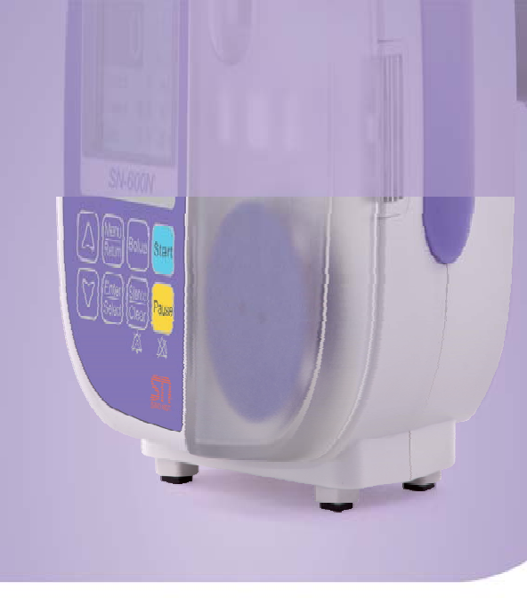
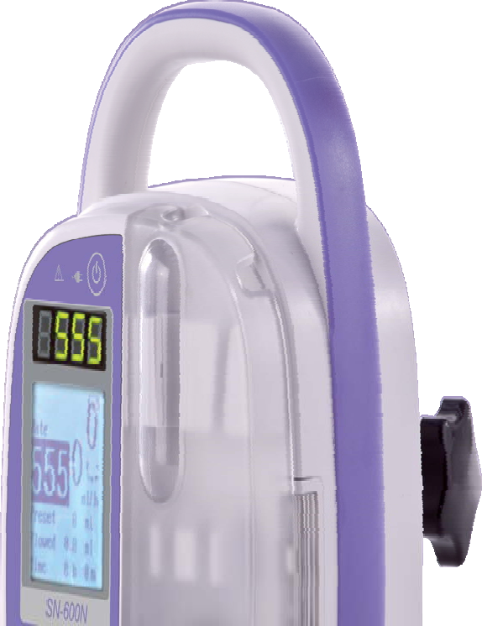
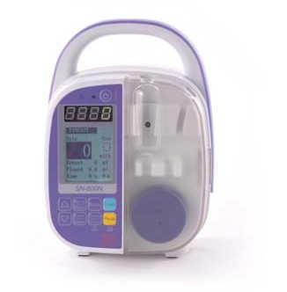

Sino Medical-Device Technology Co., Ltd. Build Quality, Build Reliability

SN-600N Enteral Nutrition Pump
Specifications:
Function:

Class I , type CF
Electric shock protection class
146 mm (width)X199.5mm (height)X114mm (depth)

Dimension
IPX4

Water proof level
Ambient Temperature: ±5o C ~ ±40o C relative humidity 20% ~ 90%, Ambient pressure: 76.0kPa ~ 106.0kPa

Operation condition
11 VA

Power consumption

The device can work for more than 5 hours at the rate of 25ml/h after full charge. It takes 10 hours for fully charge with the device shut down

Battery endurance

1.3kg (including the clamp base)
Weight

AC 100V-240V, 50HZ / 60HZ

Power supply

12V NiH 800mAh

Inner battery
1500pcs

History recording

Key tone can be set to mute, the volume has 3 levels

Keypad sound
3 levels

Alarm volume
500±2 00mmHg

Occlusion accuracy

This unique design can adjust the flow accuracy automatically for nutrition solution with different viscosity

Automatic calibration

3 levels: 200 ml/h, 400 ml/h, 600 ml/h (adjustable)

Bolus rate
±5%

Accuracy
1 ml~9999 ml

Display range of totally delivered volume
0 ml~9999 ml

Preset Volume

1 ml/h~600 ml/h

Flow Rate
parameter
Items
DUAL-CPU monitoring function | USB connector | 1500 history records
Adjust the flow accuracy by the way  of volume calibration | Water proof design for the whole device | Infusion status light can be on/off
Detection of dripping number | Abundant optic and sound alarm | Infusion set flushing function
Key lock function | The key tone can be set to mute | Bionic intermittent output
Power supply status | System time setting



V1.1

